ARTIFICIAL INTELLIGENCE

COURSE PROJECT

**Designing an Expert system for deciding where to travel using CLIPS**

**Prepared by**

**Kunal Raju Pende(IIT2019187)**

**Hafiz Ali Mohamed Hanif (IIT2019159)  
  
  
  
  
  
  
  
Date:**

**TABLE OF CONTENTS**

1. **Introduction**
2. **Related Paper**
3. **Base Papers**
4. **Literature Survey**
5. **Problem Statements and Project Scope**
6. **Tentative Proposed Approach**
7. **Experimental Dataset**
8. **Proposed Languages/Tools**
9. **Activity Time Chart**
10. **References**

# **INTRODUCTION**

**Project Title: Expert System to Decide Where to Travel**

The study of visitor decisions and choices has become increasingly important. Academic and scientific circles, as well as travel professionals and those in charge of tourist policy, are interested in the characteristics, determinants, and forecasting of tourist satisfaction. In addition, incorporating expert systems into tourism policy can be a useful tool in the decision-making process in tourist destinations for better understanding of traveler preference formation and choice. Within the domain ESTD.GR, the suggested system is an Expert System for Tourist Destinations that collaborates with user-tourist-type. It focuses on fundamental components of tourist consumer behavior, such as motivations, choices, and decisions. The selection of acceptable variables is dependent on a number of aspects, including the type of tourist, the countries of origin, the time period evaluated owing to the economic crisis, expenditures, user ratings, and the forms and types of tourism in question.

Tourism is an activity that humanity has engaged in in some form or another for a very long period. Tourism, on the other hand, has only recently been acknowledged as a significant social and economic phenomenon. Its impacts are becoming more noticeable, both on an individual level and as a result of its societal impact. "Tourism is regarded as a vital activity in the lives of nations because of its direct influence on national societies' social, cultural, educational, and economic sectors, as well as on their international relations." Because of its growing and broader impact on society, as well as the resulting need to investigate and comprehend it, it is crucial to define what tourism is, which is especially significant from a statistical standpoint. It must be apparent what is being measured in order for statistical measurements to be significant. Tourism has typically been characterized in terms of tourist/visitor activities, i.e. demand side or supply side terminology.

# **RELATED PAPERS**

| Sl.  no | Authors  Names | Paper Title | Conference/Journal Paper with year | Method/approach used | Application  domain | Dataset  used | Achieved Performance | Advantages and  Disadvantages | Feature Scope |
| --- | --- | --- | --- | --- | --- | --- | --- | --- | --- |
| 1 | Hamed Khakzad ,  Hossien  Shirazi | Tourist Expert  System With Clips | 2012 CSI Conference on Artificial Intelligence and Signal Processing | Using knowledge  Base, and  Inference engine | Clips simple user interface | - | Good interface and use of  Linguistic variable on it | Advantage:  Can difference between jungle and roads  Disadvantage: the lack of having a good interface | Also give importance to the cities development |
| 2. | Halkiopoulos , Antonopoulou | System For Recommendation tourist Destination | 4-April 2021  International Journal of Innovative Science and Research Technology | Expert system Architecture, Tourist user Ratings | SOAP, REST and JSON | - | Good web designs and give importance to ratings | Advantages: optimal tourist selection  Disadvantages: the person has to be concerned with the tourist customer decisions. | It can be associated with customized parameters that users choose themselves through an online tourism web platform. |

# **BASE PAPERS**

The base paper that we have selected for our course project in order of their priority are the

following:

1. An Expert System for Recommendation Tourist Destinations:- An Innovative Approach of Digital Marketing and Decision-Making Process.

# **LITERATURE SURVEY**

Other researchers have integrated neuroscience and neuromarketing tools and methods to test the cognitive and emotional parameters that are involved in the consumer preference of a tourist destination **(Ramsoy et al., 2019)**, which is an innovative approach to the consumer decision making process. The goal of this research is to develop an expert system that takes into account a wide range of characteristics and can help consumers choose a travel destination.

Historically, academics were motivated by a desire to learn more about how people differ, so they spent a lot of time figuring out how to quantify, chart, and explain personality traits. Trait theory is credited to the pioneering work of psychologists such as Gordon Allport, Henry Odbert Raymond Cattell, and Hans Eysenck. Trait theory has been used to try to characterize personality traits **(Gkintoni et al., 2016)**. Traits are a form of relatively constant predispositional trait. Individuals with a specific set of qualities might be expected to behave consistently in different contexts and throughout time due to their consistency.

The importance of tourism and its widespread effects were recognised in the Manila Declaration on World Tourism, which stated, "Tourism is considered an activity essential to the life of nations because of its direct effects in the social, cultural, educational, and economic sectors of national societies, as well as on their international relations," at the **World Conference on Tourism in Manila in 1980.**

Because of its growing and broader impact on society, it must be apparent what is being measured in order for statistical measurements to be significant. Tourism has typically been characterized in terms of tourist/visitor activities, i.e. demand side or supply side terminology. The demand side concept was accepted as the appropriate approach at the **WTO Ottawa Conference on Travel and Tourism Statistics in 1991**, and "tourism" was defined as "the activities of persons traveling to and staying in places outside their usual environment for not more than one year for leisure, business, and other purposes."

With a comprehensive feasibility study, McCool showed some useful aspects in developing expert systems for the hospitality industry. D. Olsen also evaluated an overview of research in strategic management in the hospitality business for the two-year period **2002-2003. In the hotel domain, E.W.T. Ngai** et al detailed the research and development of the Hotel Advisory System (HAS), a fuzzy expert system for hotel selection that helps guests conduct hotel selection using fuzzy logic. Because HAS may contain the language phrases that are commonly supplied by tourists, it makes hotel selection easier.

# **PROBLEM STATEMENT AND PROJECT SCOPE**

**Statement 1: Easy to use and straight forward user experience**

**SCOPE:**

We have to make sure that the interface that we provide to the user will be pretty much easy and straightforward considering the type of consumer that approaches the system.

People who use the system won't necessarily be comfortable with advanced user interfaces and we have to find a suitable way to tackle this problem so that it looks approachable for people from either end of the spectrum.

**Statement 2: A well made dataset to easily classify facts and narrow down user preferences**

**SCOPE:**

In order to narrow down user preferences we need to first have a well defined data set which can be described as one which has all the must have information for a person who is searching for a place to travel to.

There are alot of attributes when it comes to tourism and selecting a few from it and collecting a dataset that is large enough to consider almost all forms of inputs is a real challenge.

**Statement 3 : Application of GUI for better understandability instead of the IDE**

**SCOPE:**Even if the system is simple a proper GUI will help users to easily distinguish what goes where and also makes the system more attractive.

User interface is important to meet user expectations and support effective functionality. A well-executed user interface facilitates effective interaction between the user and the program, app or machine through contrasting visuals, clean design and responsiveness.

# **TENTATIVE PROPOSED APPROACH**

**Approach for Statement 1 and 2:**

**To come up with a user friendly and easy to handle system, we provide simple questions the user can answer to narrow down our fact search.**

By providing a set of questions it will be easier for both user and the system to decide on what aspects to focus on. 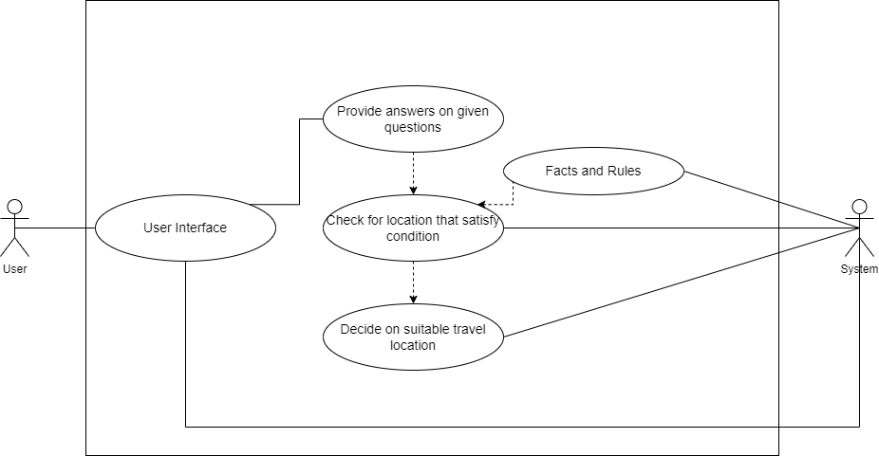

***basic use case diagram for our project***

After getting the user input the system will then trace through the fact list to find a suitable travel location for the user. We narrowed down to a large dataset which contains the attributes of:

* Place
* Transport type
* Place type
* Food type
* Weather
* Budget
* Duration

**Approach for statement 3**

**This problem can be easily approached by the application of Java GUI.**

By the use of a Java GUI framework we can create a user interface that could take needed inputs and only show the front end to the user instead of all the clutter in a IDE like the fact list and instance browser.

**EXPERIMENTAL DATASET**

***Facts.clp*** file contains all the data of favorable travel conditions for each place based on user preferences which is taken as the facts list for the expert system.

The dataset was available open source without attribution and we cross checked the validity of the given dataset by using sources like wikipedia.org and makemytrip.com.

**PROPOSED LANGUAGES/TOOLS**

The proposed languages and tools that would be used in this project are

* CLIPS IDE
* CLIPS JNI
* Java GUI framework

**ACTIVITY TIME CHART**

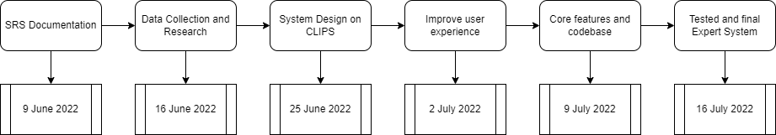

**REFERENCES**

* ***”Tourism expert system with clips using PFC”*** - Hamed Khakzad, Hossein Shirazi - Department of Computer Engineering Malek Ashtar University of Tehran, Iran.
* ***“System For Recommendation tourist Destination”*** *-*